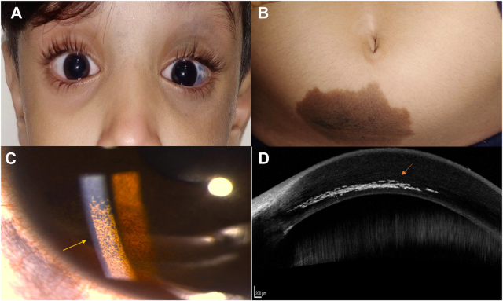

A 6-year-old girl presented (A) with congenital unilateral slate-grey hyperpigmentation of the eyelids, cheek, sclera, and (B) she had abrown, macular periumbilical dermal nevus. She had an intracorneal, brown, carpet-like lesion within the inferonasal corneal stroma,sparing the pupillary area. Her vision and intraocular pressure were within normal limits. Dendrite-like pigmentation fanned out intrastromally (C) within posterior stroma as on anterior-segment OCT (D), adjacent to scleral pigmentation.

**Intracorneal melanocytosis and oculodermal melanocytosis.**